**Price/Rating**

1. Are more expensive wines more highly rated?

The below scatterplot shows us that the most expensive wines are not necessarily the highest rated. To determine this, I sorted our dataset by wine price (x-axis) and wine ratings (y-axis) and combined them on the scatterplot to answer the question “Does more expensive wine have higher ratings?”. This finding was surprising because we expected that expensive wines would be rated in the “Classic” (98-100 points) but most are in the “Superb” category (94-97 points). This diagram also shows that the most expensive wines are the outliers in this dataset.

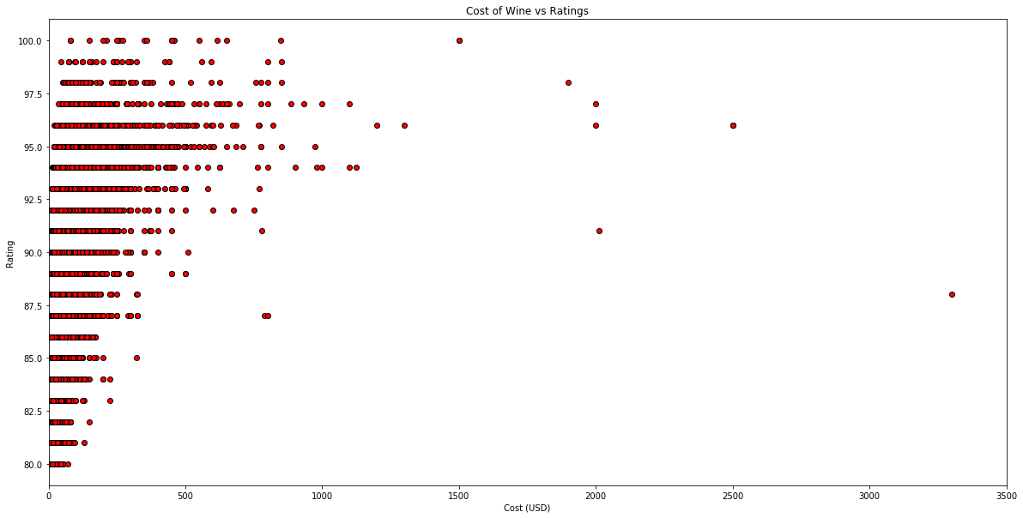

-The following scatterplot shows us that the majority of wines are under $150.00. Also, we can see that the cheapest wines have the worst ratings, as we expected. For this, I used the same graph as before, but changed the limit so the display was zoomed in to allow us to see trends on the y-axis more clearly.

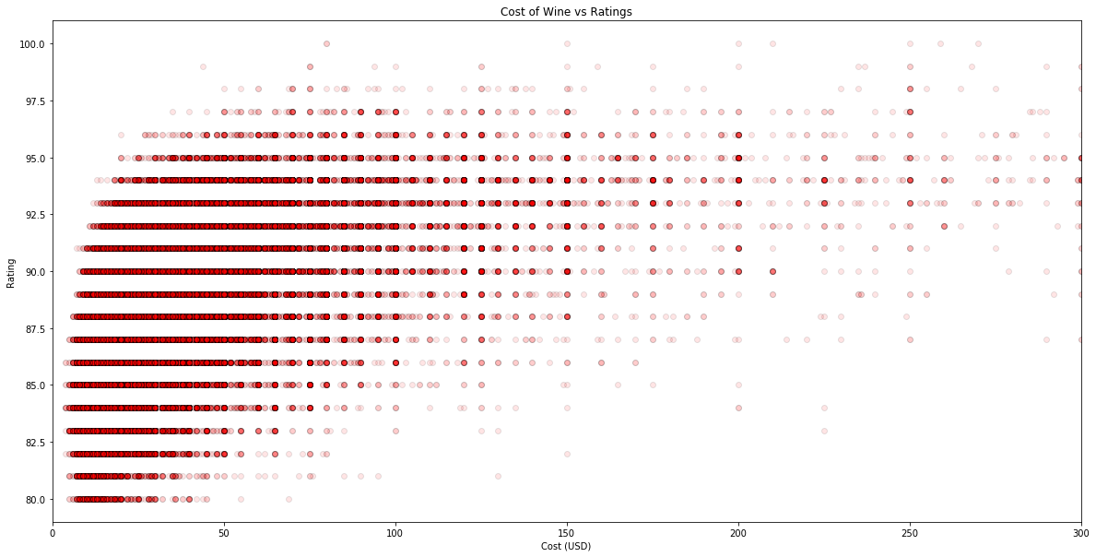

7. Which countries produce the lowest rated & highest rated wines?

8. Which countries produce the most expensive and least expensive wines?

The top twenty countries producing the most expensive wines are those mostly in Western Europe and North America. The largest outlier is England with a median price per bottle about $50, while most countries median falls around $30 per bottle. The twenty countries producing the least expensive bottles are those not normally known for wine production. Most of these countries are in Eastern Europe and South America. The lowest average bottle price is Ukraine and Romania with an average of less than $10 per bottle, with all median prices falling below $20 per bottle.

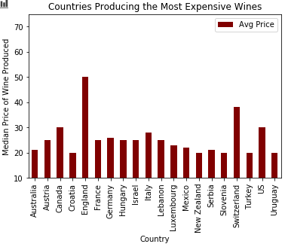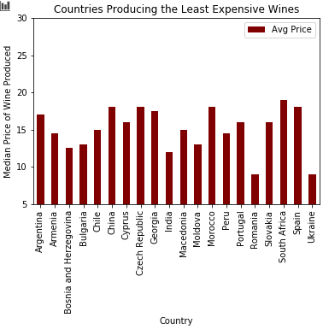

9. Does better wine cost more?

**Location**

2. Which part of the world produces higher rated wines?

The data is compared to the average score of the rating against countries. Numbers of reviews are shown as colors of the dots to show which countries are popular and reviewed most.

Among the countries with more than 1000 reviews, Austria wine has the highest rating. Germany has a close score, a little less than 90. Average rating between 88 to 89 was most competitive with 7 countries rated in that bucket.

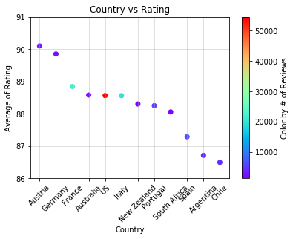

3. Which US State produces the highest rated wines?

California wines had the most reviews expected. When comparing the averaging ratings with States more than 500 reviews, Oregon wine has the highest rating. Washington wines were very close in the score. California wines follow the next.

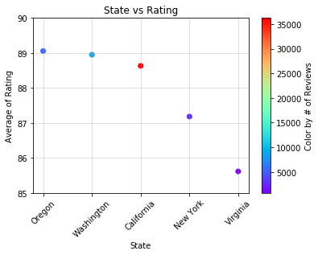

4. Where are the best wines produced?

When grouping countries by continent, wines from Europe and North America have the highest ratings. They are two continents with most reviews. The surprise was wines from Latin/South America have the lowest wines when Chile and Argentina are quite famous for wines.

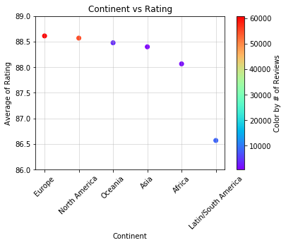

**Time**

5. Which vintage year is more highly rated?

8. Is wine getting better year by year?

After grouping wines by year and then averaging their rating, I charted out the average ratings in order to compare then to each other. 2013 was found to be the best year and 2016 was found to be the worst year but both were by very small margins. So overall there is not a lot of change in wine quality over the years looked at.

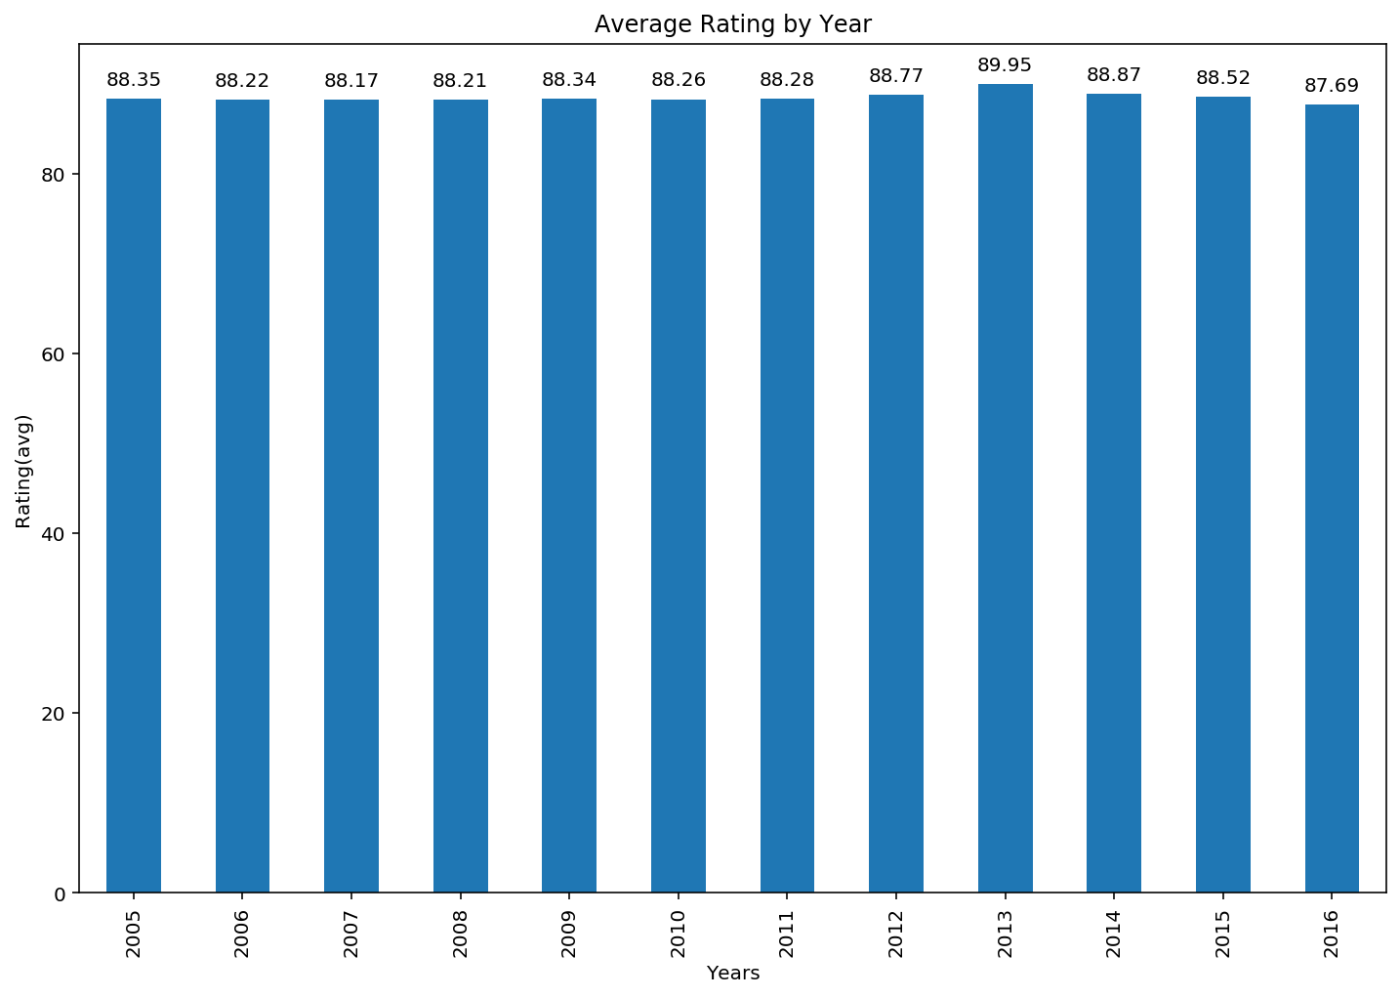

9. How much money does it cost to get a highly rated wine by country?

In general the highly rated wines cost between $30-40 worldwide, with a few exceptions. We had anticipated seeing a little more variety based on the country, but the range (90-100 rating) was fairly large. When narrowed down to only the top wines (98-100), prices were much higher and more varied like we expected. We also noticed that much fewer companies were represented here. Median price was used instead of average due to the presence of outliers.

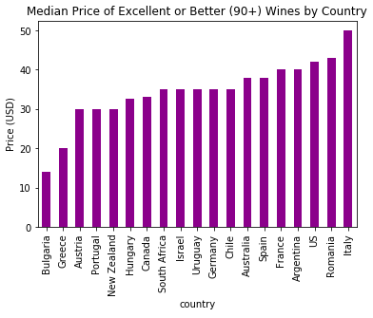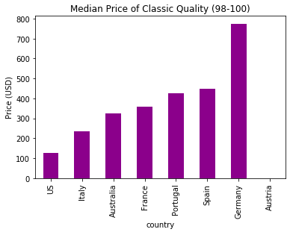

6. Which variety of wine is more highly rated?

Ratings by variety varied a little more than we expected. We initially assumed when scoring a Merlot, for example, the rating would be determined based on how good or bad it was for a Merlot. In reality, there were wines that did score quite a bit higher on average than others. Nebbiolo, and Italian wine, ended up being the clear winner.

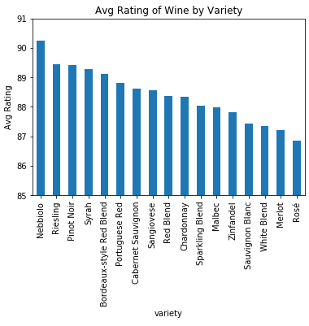

**Impractical questions:**

-Do some reviewers give higher scores?

-Which wineries produce the highest/lowest rated wines?

-Which description of wines are more highly rated?

When initially looking at our data, we were interested in answering these questions as well. They were eventually cut from the final analysis, though we did work on them at some point.

The scoring based on reviewers didn’t prove interesting enough to be included. There was some variation between reviewers and which countries they typically reviewed, but this wasn’t as related to our goal for the data.

Data on the wines produced by particular wineries would likely be more interesting on a smaller scope (ex. A wine tour through Italy), but due to the large number of unique wineries and our target audience for this presentation, the data was not as meaningful.

Parsing through the description of wines was ultimately outside of our skillset. It likely would have yielded interesting results to see if certain keywords were tied to better wines (fruity, aromatic, etc) but figuring out how to accomplish this ultimately proved to difficult.